AVANI SHAJI KRISHNA

22BTRAD007

CUSTOM CLASS DEFINTION

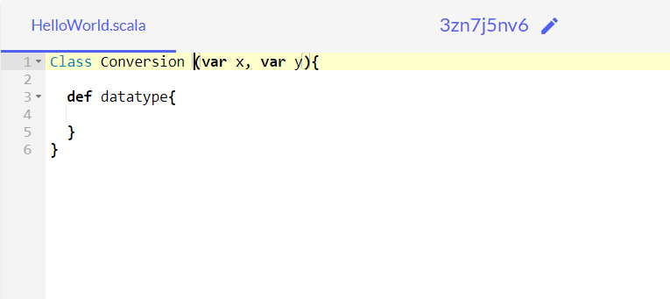

Basic Construct of the Programming:

PSEUDO CODE:

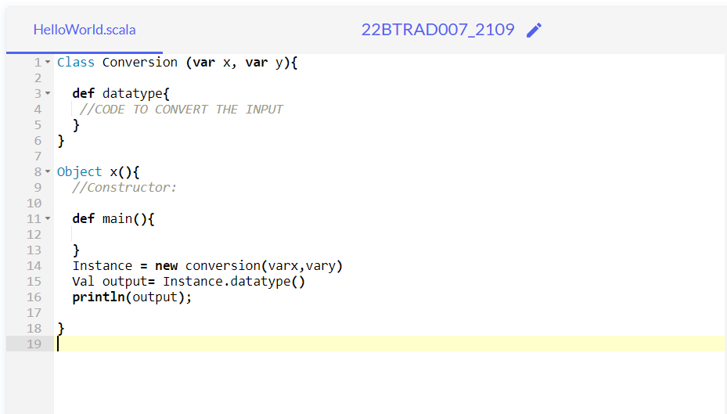

CODE:

object Change {

def change_type(x:Int): String = {

val result=x.toString

println("Type of result is:"+result.getClass)

result

}

}

object Main {

def main(args: Array[String]): Unit = {

print("Type number:")

var input:Int =scala.io.StdIn.readInt()

println(input)

print("Type datatype to which it has to be changed:")

val type1=scala.io.StdIn.readLine()

println(type1)

println("Result is "+Change.change_type(input))

}

}

CODE AND OUTPUT:

